Report based on my drupal website

Introduction:
Guitar fans is a website based on online advertising of guitars where people can find information about many kinds of guitars of all around the world. People who are really interested to buy guitars can have some ideas if they have a look into there particular guitar section as there are specific section of guitars. If someone wants to know about some other guitars which are not available in the website page they can contact with the mentor of the website using the contact or advertising inquiery page.

Modules:
Different types of module have been used to build up the website. I have used
Contents
Articles
Basic pages
Side bars
Theme
Block contents
Menu
Reviews
Navigation
Images. Etc. for the functionality of my website.

Screenshots:

Contents
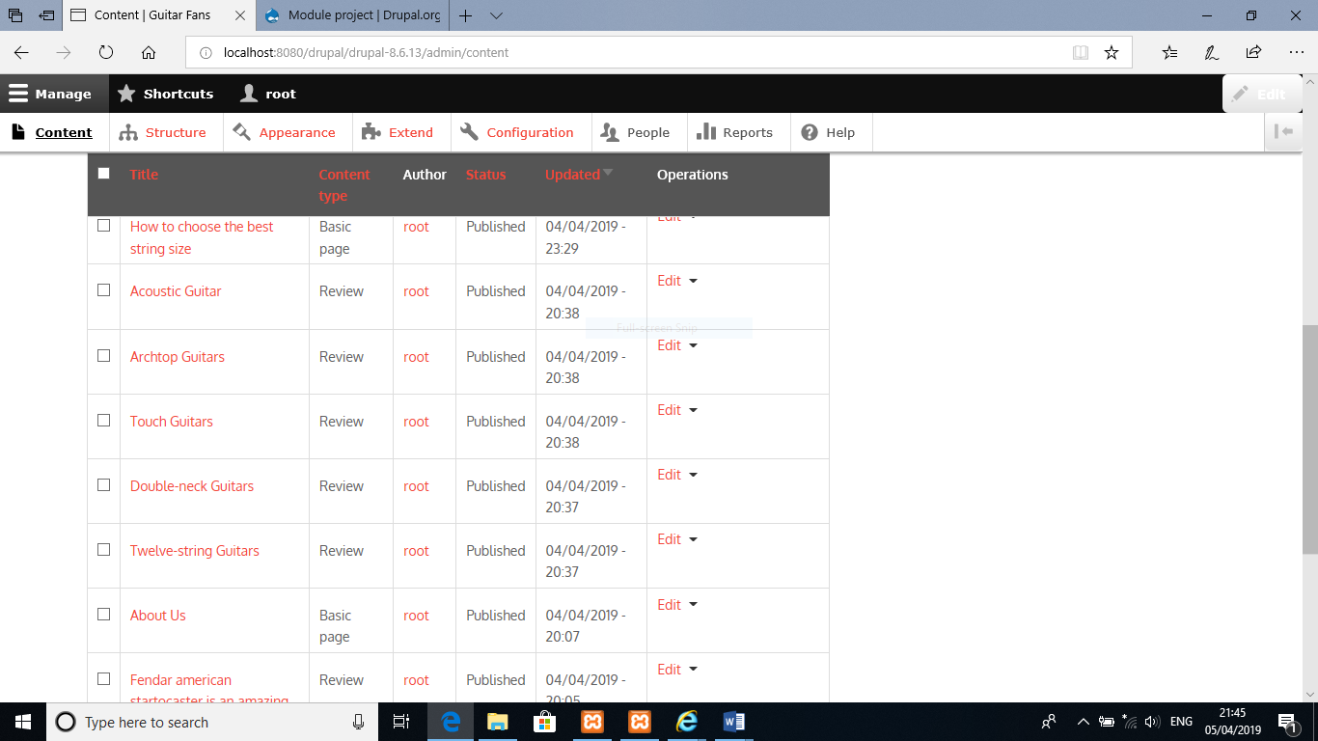

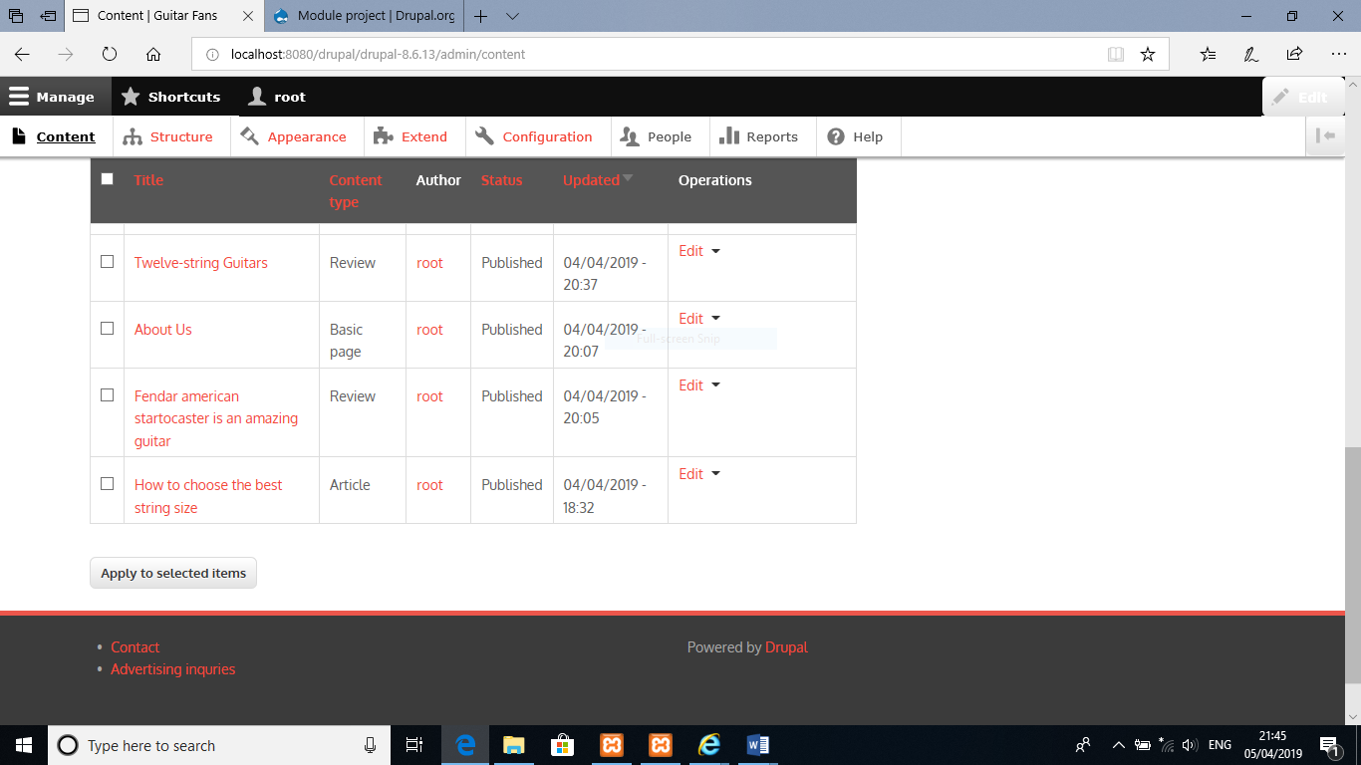

Articles
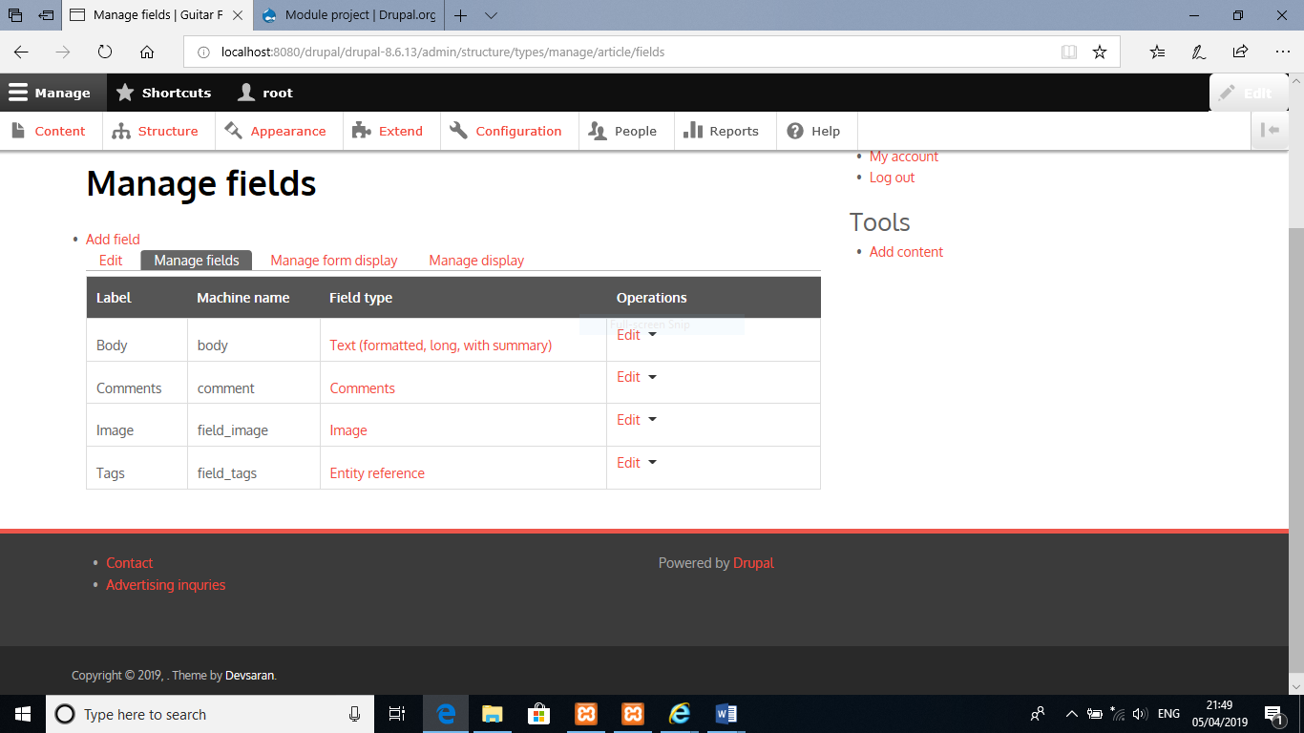

Theme
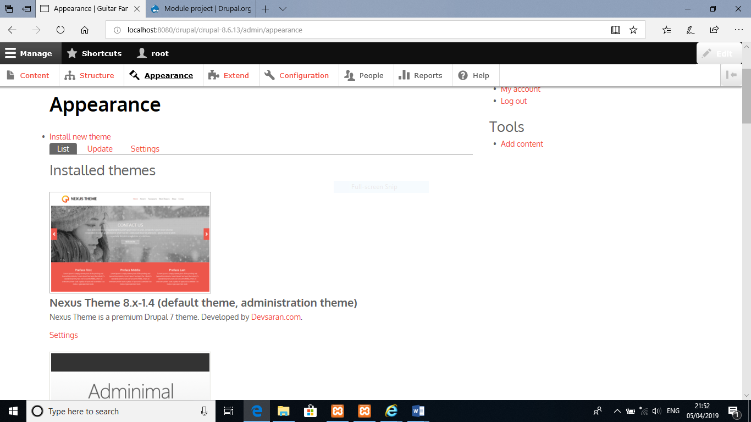

Block Layout
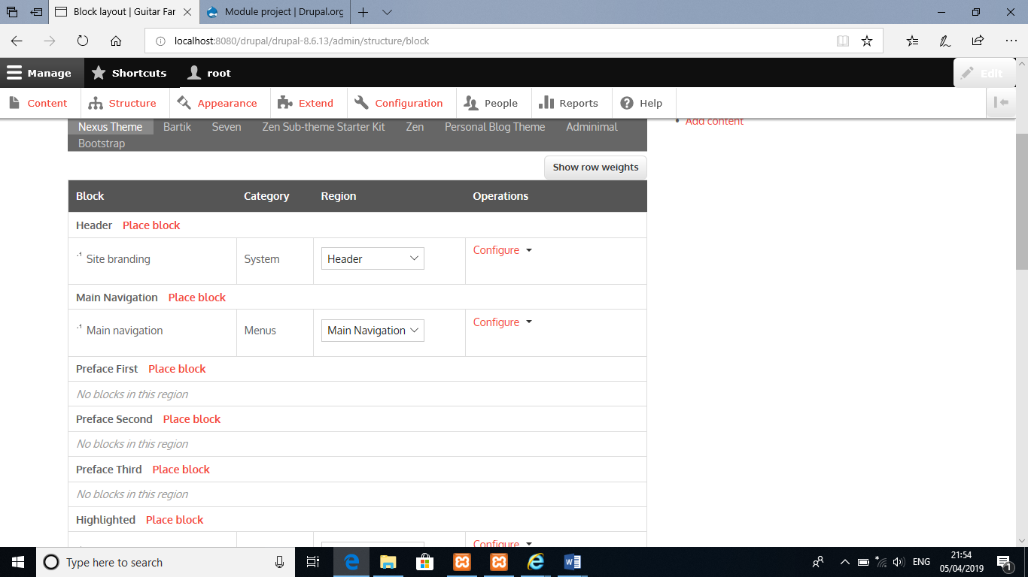

Menu
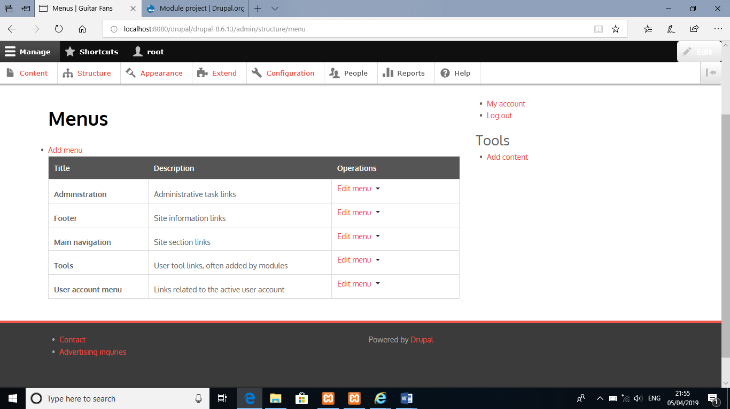

Content types
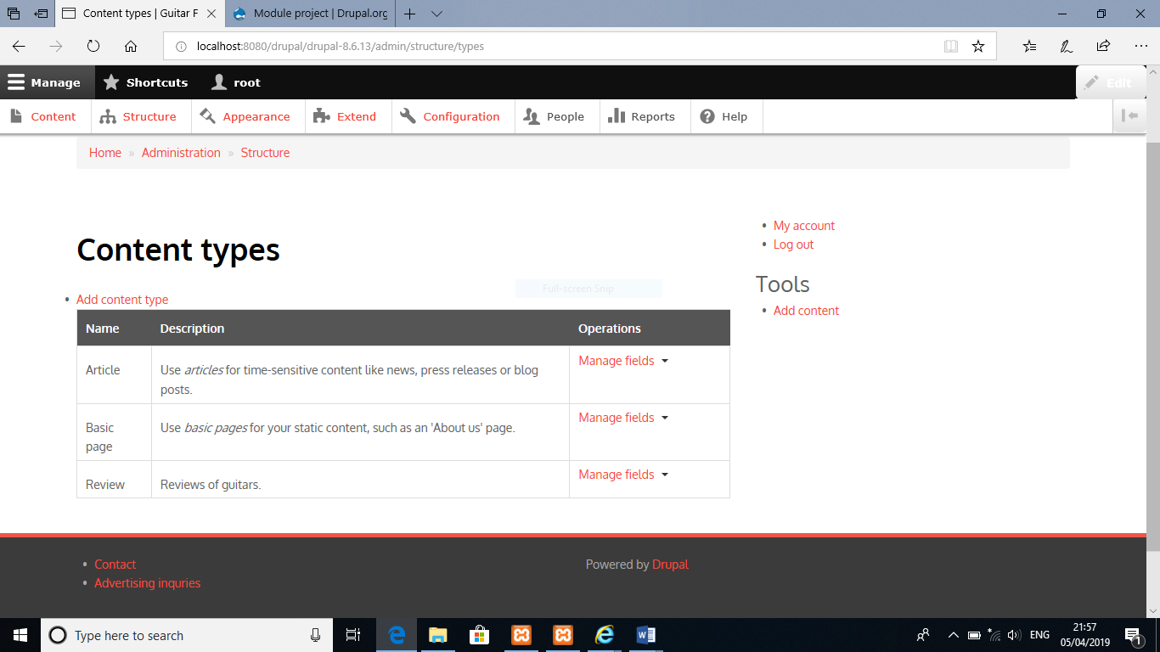

Basic page
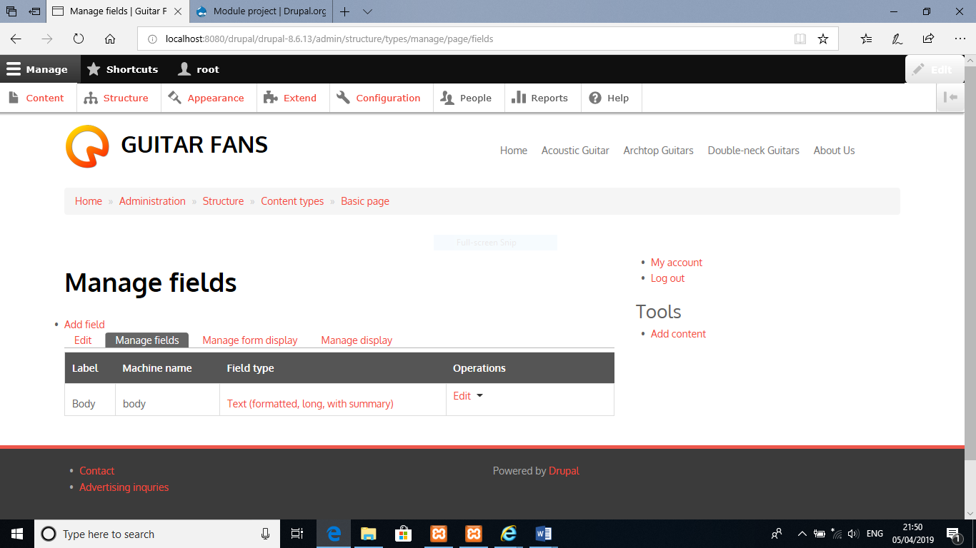

As a beginner I am pretty happy with the work that I have done so far. But it could be more attractive if I could work some more time on it using some particular guitars music videos on it in each section and some audio clips of the guitars as well. It could be better if I could use some more articles containing informations about more guitars and also some more work on the theme to make the look better .

As I am using an external web hosting so the URL gonna be
http://localhost:8080/drupal/drupal-8.6.13/
Admin username: root
Admin password: a123456789a

